**CSE 30342 Lab 3 Group Submission**

Group Members: **Daniel Noronha, Ricky Ortiz, Nguyen Nguyen**

CRC Machine (Github Repo) directory: dropbox/VLSI/boyz

**Part 1c - Layout**

**Part 1d – Extracted View**

**Part 1d – Netlist**

t 9 a input

t 8 b input

t 7 c input

t 6 d input

t 4 e input

t 5 gnd! inputOutput

t 10 vdd! inputOutput

t 11 y output

n 0 /12

n 1 /11

n 2 /10

n 3 /9

n 4 /e

n 5 /gnd!

n 6 /d

n 7 /c

n 8 /b

n 9 /a

n 10 /vdd!

n 11 /y

; pmos4 Instance /+9 = auLvs device Q0

d pmos D G S B (p D S)

i 0 pmos 1 7 11 10 " m 1 l 600e-9 w 9e-6 "

; pmos4 Instance /+8 = auLvs device Q1

i 1 pmos 11 4 1 10 " m 1 l 600e-9 w 9e-6 "

; pmos4 Instance /+6 = auLvs device Q2

i 2 pmos 10 9 0 10 " m 1 l 600e-9 w 9e-6 "

; pmos4 Instance /+5 = auLvs device Q3

i 3 pmos 0 8 1 10 " m 1 l 600e-9 w 9e-6 "

; nmos4 Instance /+4 = auLvs device Q4

d nmos D G S B (p D S)

i 4 nmos 5 7 2 5 " m 1 l 600e-9 w 3e-6 "

; nmos4 Instance /+3 = auLvs device Q5

i 5 nmos 2 4 11 5 " m 1 l 600e-9 w 3e-6 "

; nmos4 Instance /+2 = auLvs device Q6

i 6 nmos 11 6 3 5 " m 1 l 600e-9 w 3e-6 "

; nmos4 Instance /+1 = auLvs device Q7

i 7 nmos 3 9 5 5 " m 1 l 600e-9 w 3e-6 "

; nmos4 Instance /+0 = auLvs device Q8

i 8 nmos 5 8 3 5 " m 1 l 600e-9 w 3e-6 "

; pmos4 Instance /+7 = auLvs device Q9

i 9 pmos 1 6 10 10 " m 1 l 600e-9 w 4.5e-6 "

**Part 1e – Schematic**

**Part 1e – Waveform**

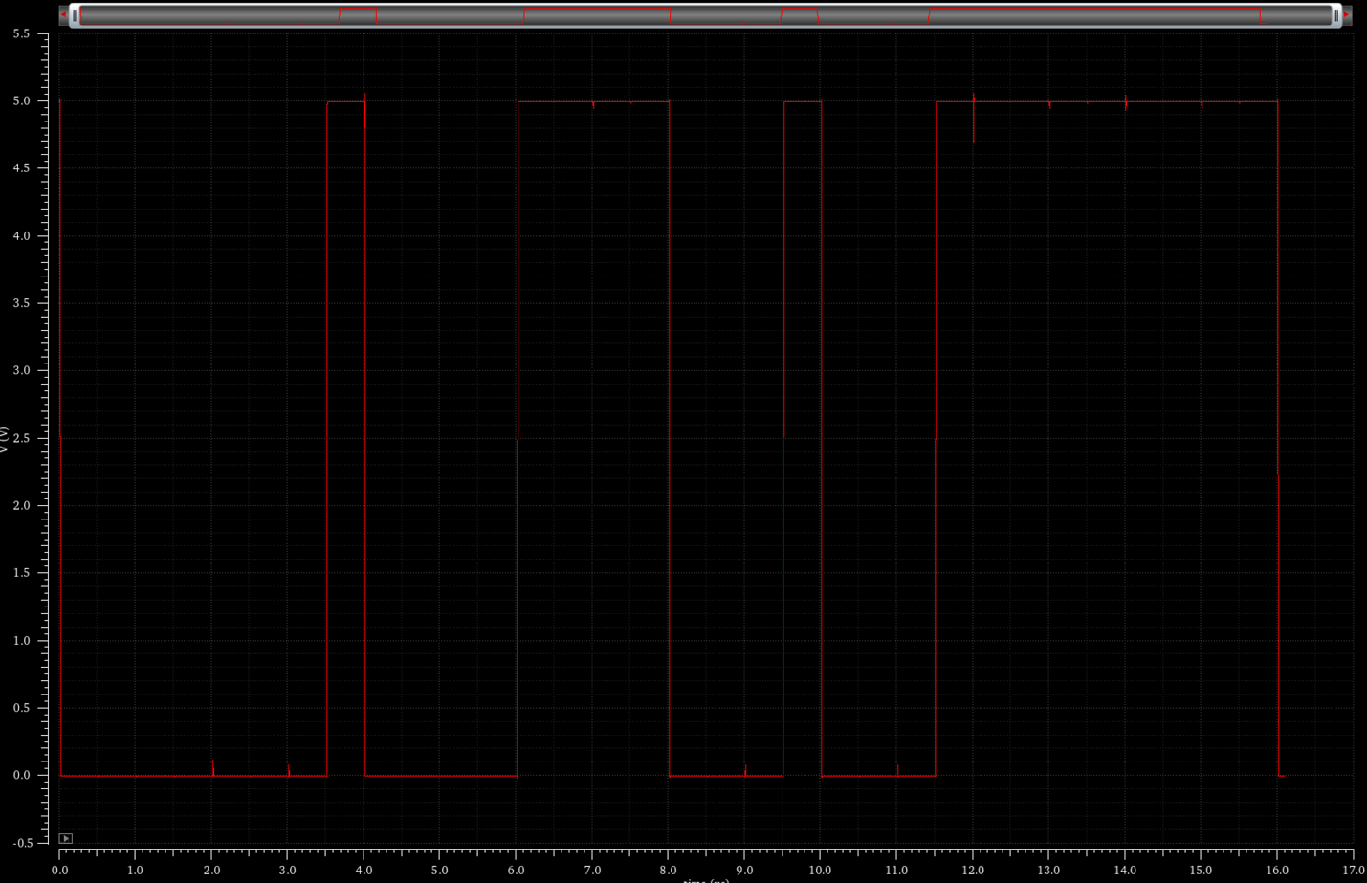

**Part 1e – Netlist**

// Library name: lab3_boyz_dnoronha

// Cell name: adv_logic

// View name: schematic

subckt adv_logic a b c d e y

P4 (y e net21 vdd!) ami06P w=9u l=600n as=1.35e-11 ad=1.35e-11 \

ps=21.0u pd=21.0u m=1 region=sat

P3 (net21 d vdd! vdd!) ami06P w=4.5u l=600n as=6.75e-12 ad=6.75e-12 \

ps=12.0u pd=12.0u m=1 region=sat

P2 (y c net21 vdd!) ami06P w=9u l=600n as=1.35e-11 ad=1.35e-11 \

ps=21.0u pd=21.0u m=1 region=sat

P1 (net21 b net32 vdd!) ami06P w=9u l=600n as=1.35e-11 ad=1.35e-11 \

ps=21.0u pd=21.0u m=1 region=sat

P0 (net32 a vdd! vdd!) ami06P w=9u l=600n as=1.35e-11 ad=1.35e-11 \

ps=21.0u pd=21.0u m=1 region=sat

V1 (0 0) vsource type=dc dc=0

V0 (vdd! 0) vsource type=dc dc=5

N4 (net30 c 0 0) ami06N w=3u l=600n as=4.5e-12 ad=4.5e-12 ps=9u pd=9u \

m=1 region=sat

N3 (y e net30 0) ami06N w=3u l=600n as=4.5e-12 ad=4.5e-12 ps=9u pd=9u \

m=1 region=sat

N2 (net19 b 0 0) ami06N w=3u l=600n as=4.5e-12 ad=4.5e-12 ps=9u pd=9u \

m=1 region=sat

N1 (net19 a 0 0) ami06N w=3u l=600n as=4.5e-12 ad=4.5e-12 ps=9u pd=9u \

m=1 region=sat

N0 (y d net19 0) ami06N w=3u l=600n as=4.5e-12 ad=4.5e-12 ps=9u pd=9u \

m=1 region=sat

ends adv_logic

// End of subcircuit definition.

// Library name: lab3_boyz_dnoronha

// Cell name: sim_adv_circuit

// View name: schematic

I0 (A B C D E Y) adv_logic

V4 (A 0) vsource type=pulse val0=0 val1=5 period=1u delay=10n rise=2.5n \

fall=2.5n width=497.5n

V3 (B 0) vsource type=pulse val0=0 val1=5 period=2u delay=12.5n rise=2.5n \

fall=2.5n width=997.5n

V2 (C 0) vsource type=pulse val0=0 val1=5 period=4u delay=15n rise=2.5n \

fall=2.5n width=1.9975u

V1 (D 0) vsource type=pulse val0=0 val1=5 period=8u delay=10n rise=2.5n \

fall=2.5n width=3.9975u

V0 (E 0) vsource type=pulse val0=0 val1=5 period=16u delay=15n rise=2.5n \

fall=2.5n width=7.9975u

**Part 2f – Schematic**

**Part 2f – Symbol**

**Part 2f – Layout**

**Part 2f – LVS Netlist**

t 11 a input

t 10 b input

t 9 c input

t 8 d input

t 6 e input

t 5 f input

t 7 gnd! inputOutput

t 12 vdd! inputOutput

t 13 y output

n 0 /14

n 1 /13

n 2 /12

n 3 /11

n 4 /10

n 5 /f

n 6 /e

n 7 /gnd!

n 8 /d

n 9 /c

n 10 /b

n 11 /a

n 12 /vdd!

n 13 /y

; pmos4 Instance /+11 = auLvs device Q0

d pmos D G S B (p D S)

i 0 pmos 13 9 1 12 " m 1 l 600e-9 w 6e-6 "

; pmos4 Instance /+10 = auLvs device Q1

i 1 pmos 1 8 13 12 " m 1 l 600e-9 w 6e-6 "

; pmos4 Instance /+9 = auLvs device Q2

i 2 pmos 13 10 0 12 " m 1 l 600e-9 w 6e-6 "

; pmos4 Instance /+8 = auLvs device Q3

i 3 pmos 0 11 12 12 " m 1 l 600e-9 w 6e-6 "

; pmos4 Instance /+7 = auLvs device Q4

i 4 pmos 12 5 1 12 " m 1 l 600e-9 w 6e-6 "

; pmos4 Instance /+6 = auLvs device Q5

i 5 pmos 1 6 12 12 " m 1 l 600e-9 w 6e-6 "

; nmos4 Instance /+5 = auLvs device Q6

d nmos D G S B (p D S)

i 6 nmos 7 9 2 7 " m 1 l 600e-9 w 4.5e-6 "

; nmos4 Instance /+4 = auLvs device Q7

i 7 nmos 2 8 3 7 " m 1 l 600e-9 w 4.5e-6 "

; nmos4 Instance /+3 = auLvs device Q8

i 8 nmos 3 10 13 7 " m 1 l 600e-9 w 4.5e-6 "

; nmos4 Instance /+2 = auLvs device Q9

i 9 nmos 13 11 3 7 " m 1 l 600e-9 w 4.5e-6 "

; nmos4 Instance /+1 = auLvs device Q10

i 10 nmos 3 5 4 7 " m 1 l 600e-9 w 4.5e-6 "

; nmos4 Instance /+0 = auLvs device Q11

i 11 nmos 4 6 7 7 " m 1 l 600e-9 w 4.5e-6 "

**Part 2i – Simulation Schematic**

**Part 2i – Waveform (before power spike mitigation using delays)**

**Part 2i – Waveform (after power spike mitigation using delays)**

**Part 2i – Spectre Simulation Netlist**

// Library name: lab3_boyz_dnoronha

// Cell name: part2_circuit

// View name: schematic

subckt part2_circuit a b c d e f y

P5 (y d net33 vdd!) ami06P w=6u l=600n as=9e-12 ad=9e-12 ps=15.0u \

pd=15.0u m=1 region=sat

P4 (y c net33 vdd!) ami06P w=6u l=600n as=9e-12 ad=9e-12 ps=15.0u \

pd=15.0u m=1 region=sat

P3 (net33 f vdd! vdd!) ami06P w=6u l=600n as=9e-12 ad=9e-12 ps=15.0u \

pd=15.0u m=1 region=sat

P2 (net33 e vdd! vdd!) ami06P w=6u l=600n as=9e-12 ad=9e-12 ps=15.0u \

pd=15.0u m=1 region=sat

P1 (y b net37 vdd!) ami06P w=6u l=600n as=9e-12 ad=9e-12 ps=15.0u \

pd=15.0u m=1 region=sat

P0 (net37 a vdd! vdd!) ami06P w=6u l=600n as=9e-12 ad=9e-12 ps=15.0u \

pd=15.0u m=1 region=sat

N5 (net35 e 0 0) ami06N w=4.5u l=600n as=6.75e-12 ad=6.75e-12 ps=12.0u \

pd=12.0u m=1 region=sat

N4 (net36 c 0 0) ami06N w=4.5u l=600n as=6.75e-12 ad=6.75e-12 ps=12.0u \

pd=12.0u m=1 region=sat

N3 (net27 f net35 0) ami06N w=4.5u l=600n as=6.75e-12 ad=6.75e-12 \

ps=12.0u pd=12.0u m=1 region=sat

N2 (net27 d net36 0) ami06N w=4.5u l=600n as=6.75e-12 ad=6.75e-12 \

ps=12.0u pd=12.0u m=1 region=sat

N1 (y b net27 0) ami06N w=4.5u l=600n as=6.75e-12 ad=6.75e-12 ps=12.0u \

pd=12.0u m=1 region=sat

N0 (y a net27 0) ami06N w=4.5u l=600n as=6.75e-12 ad=6.75e-12 ps=12.0u \

pd=12.0u m=1 region=sat

V1 (0 0) vsource type=dc dc=0

V0 (vdd! 0) vsource type=dc dc=5

ends part2_circuit

// End of subcircuit definition.

// Library name: lab3_boyz_dnoronha

// Cell name: sim_part2_circuit

// View name: schematic

I0 (A B C D E F Y) part2_circuit

V5 (A 0) vsource type=pulse val0=0 val1=5 period=1u delay=10n rise=2.5n \

fall=2.5n width=497.5n

V4 (B 0) vsource type=pulse val0=0 val1=5 period=2u delay=12.5n rise=2.5n \

fall=2.5n width=997.5n

V3 (C 0) vsource type=pulse val0=0 val1=5 period=4u delay=12.5n rise=2.5n \

fall=2.5n width=1.9975u

V2 (D 0) vsource type=pulse val0=0 val1=5 period=8u delay=12.5n rise=2.5n \

fall=2.5n width=3.9975u

V1 (E 0) vsource type=pulse val0=0 val1=5 period=16u delay=10n rise=2.5n \

fall=2.5n width=7.9975u

V0 (F 0) vsource type=pulse val0=0 val1=5 period=32u delay=10n rise=2.5n \

fall=2.5n width=15.9975u